 **Course Code: BCSE308P**

**Course Name: Computer Networks Lab**

**Assessment – 1**

**Name: Shivam Dave**

**Reg. No.: 21BCB0107**

**Basic Networking Devices**

|  |  |  |  |
| --- | --- | --- | --- |
| **Device Name** | **Fundamental Characteristics** | **Layer** | **Image** |
| **Hub** | The main purpose of a hub is to connect all present network devices together on a predefined internal network. Hub is a device consisting of multiple ports that accept ethernet connections from network devices. | Layer 1 or the physical layer |  |
| **Repeater** | A repeater is a powerful network hardware device that regenerates an incoming signal from the sender before retransmitting it to the receiver. It is also known as a signal booster, and it helps in extending the coverage area of networks. The Incoming data can be in optical, wireless or electrical signals | It operates in OSI layer 1 | **What are Repeaters in Computer Network? - Shiksha Online** |
| **Switch** | Now, a switch is very similar to a hub. It also has multiple ports that accept the Ethernet connections from various network devices present. But unlike our hub, a switch is the intelligent one. A switch can learn the physical addresses of the devices that are actually connected to it, and then it stores these physical addresses called MAC addresses in its table. So whenever a data packet is sent to a switch, it’s only directed to the intended destination port, unlike a hub where a hub will just rebroadcast the data to every port. | It operates in the second layer i.e Datalink layer |  |
| **Router** | It serves two primary functions: managing traffic between these networks by forwarding data packets to their intended IP addresses, and allowing multiple devices to use the same Internet connection. | Routers are networking devices operating at layer 3 or a network layer of the OSI model | **Explain Following Network Device with Diagram: Router - Computer Science 2  | Shaalaa.com** |
| **Network bridges** | Bridges are used to connect two or more hosts or network segments together. The basic role of bridges in network architecture is storing and forwarding frames between the different segments that the bridge connects. They use hardware Media Access Control (MAC) addresses for transferring frames. By looking at the MAC address of the devices connected to each segment, bridges can forward the data or block it from crossing. Bridges can also be used to connect two physical LANs into a larger logical LAN. | Bridges work only at the Physical and Data Link layers of the OSI model. | **Network bridge explained - Study CCNA** |
| **Gateway** | Gateways normally work at the Transport and Session layers of the OSI model. At the Transport layer and above, there are numerous protocols and standards from different vendors; gateways are used to deal with them. | The gateway also operates at the data link layer (Layer 2) of the OSI network model. | **Network Gateways Selection Guide: Types, Features, Applications | GlobalSpec** |
| **Firewall** | A firewall is a network security device, either hardware or software-based, which monitors all incoming and outgoing traffic and based on a defined set of security rules it accepts, rejects or drops that specific traffic. | Firewalls typically work on the network layer, the transport layer. | **What is a Firewall in Networking and its types | Computer Network** |
| **Wireless access point** | Wireless access points (WAPs) consist of a transmitter and receiver (transceiver) device used to create a wireless LAN (WLAN). Access points typically are separate network devices with a built-in antenna, transmitter and adapter. APs use the wireless infrastructure network mode to provide a connection point between WLANs and a wired Ethernet LAN. | An Access Point is a Layer 2 device and therefore works on Layers 1 and 2. |  |
| **Modem** | Modems (modulators-demodulators) are used to transmit digital signals over analog telephone lines. Thus, digital signals are converted by the modem into analog signals of different frequencies and transmitted to a modem at the receiving location. The receiving modem performs the reverse transformation and provides a digital output to a device connected to a modem, usually a computer. | Modems also operate on Datalink layer | **Difference between Modem and Router - javatpoint** |

**Q2) Basic Networking Commands**

**1)Ping Command**

**Uses:**

The ping command is one of the most often used networking utilities for detecting devices on a network and for troubleshooting network problems.

**Syntax:**

The general format is ping hostname or ping IPaddress.

ping google.com

**Output:**

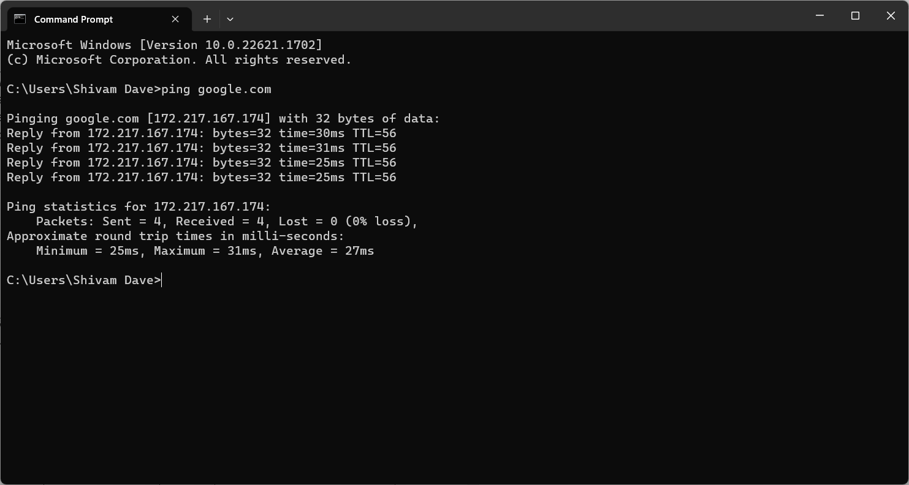

**2) ipconfig Command**

**Uses:**

Another indispensable and frequently used utility that is used for finding network information about your local machine like IP addresses, DNS addresses etc

**Syntax:**

ipconfig /parameter_name.

**Output:**

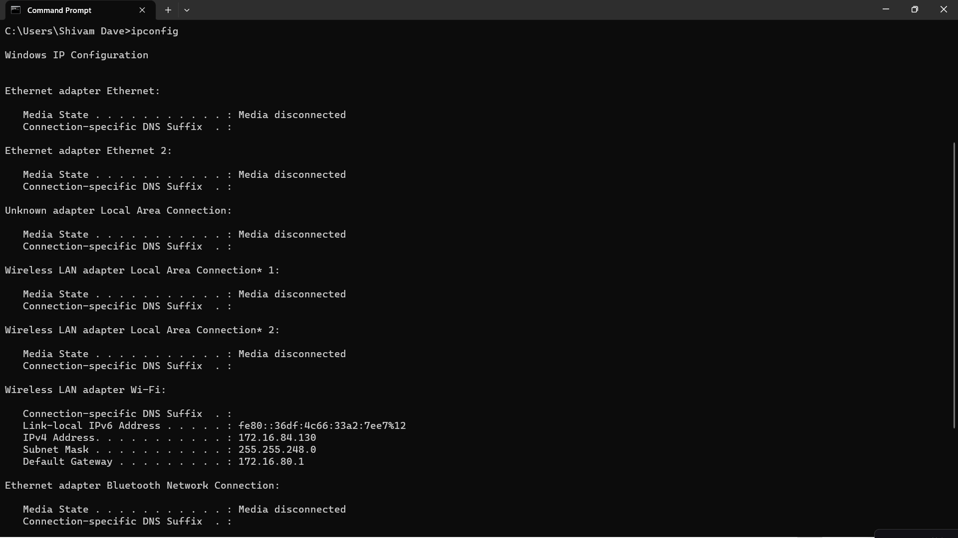

**3)Hostname Command**

**Uses:**

A very simple command that displays the host name of your machine. This is much quicker than going to the control panel>system route.

**Syntax:**

hostname

**Output:**

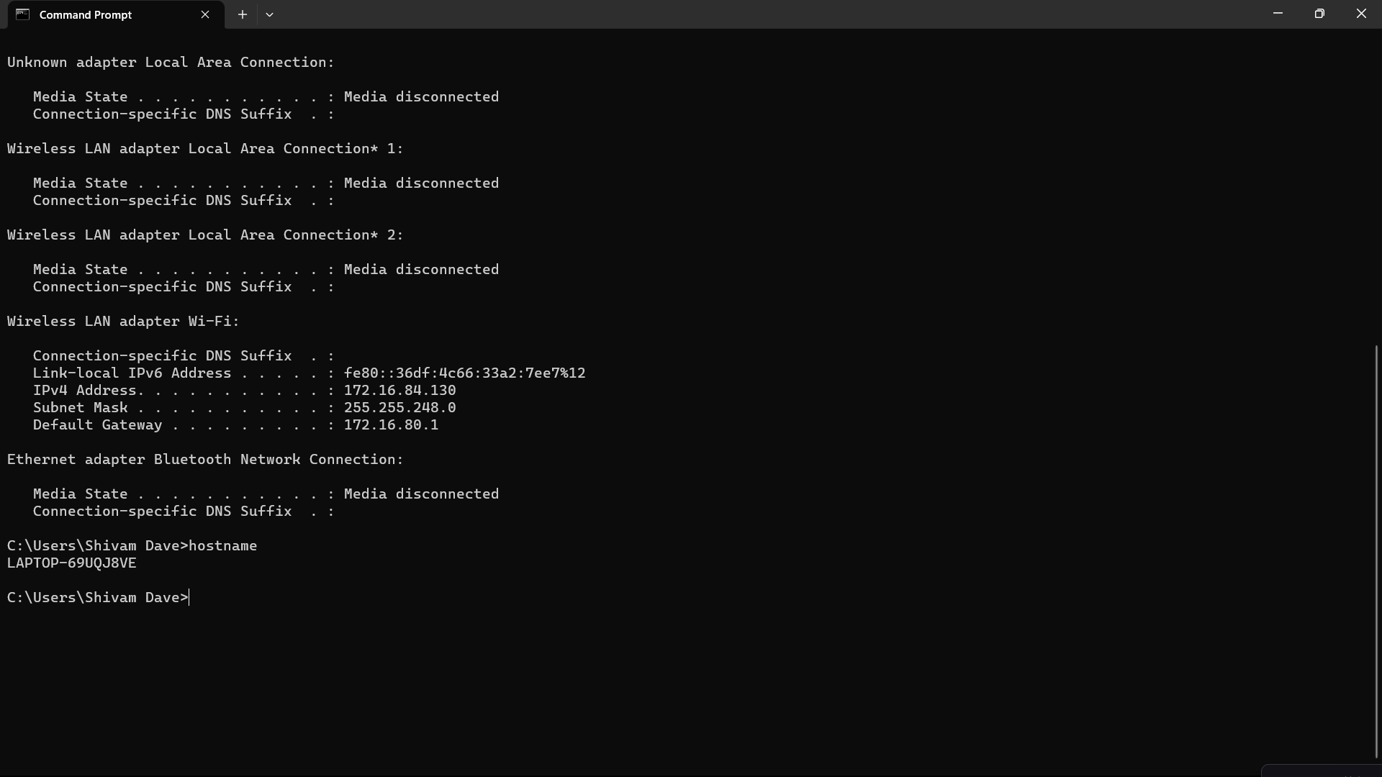

**4) getmac Command**

**Uses:**

Another very simple command that shows the MAC address of your network interfaces

**Syntax**: getmac - Find MAC Address of your Local Computer

**Output:**

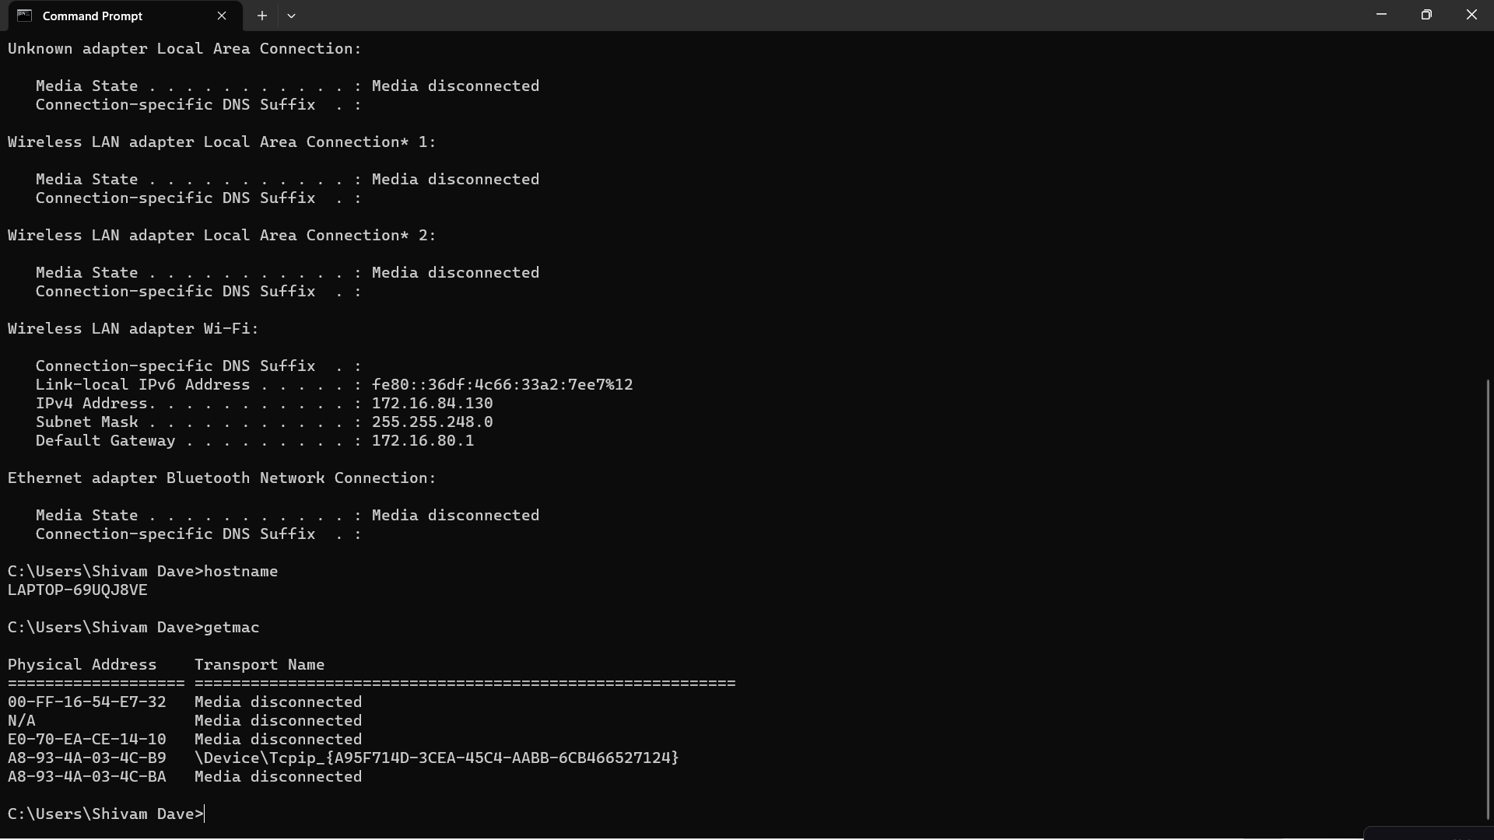

**5)Nslookup command**

**Uses:**

main use of nslookup is for troubleshooting DNS related problems. Nslookup can be use in interactive and non-interactive mode.

To use in interactive mode type nslookup at the command line and hit return. We should get an nslookup command prompt.

**Syntax**: nslookup [option]

**Output:** 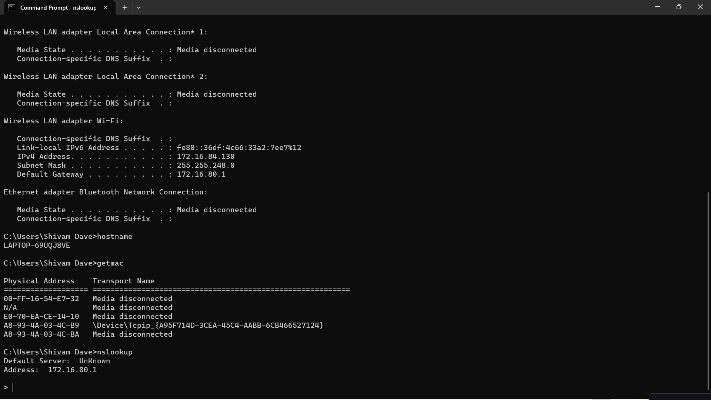

**6) Netstat**

**Uses:**

Netstat displays a variety of statistics about a computers active TCP/IP connection.

Netstat command displays various network related information such as network connections,routing tables, interface statistics,

multicast memberships etc.,

**Syntax**:

netstat -a

**Output:**

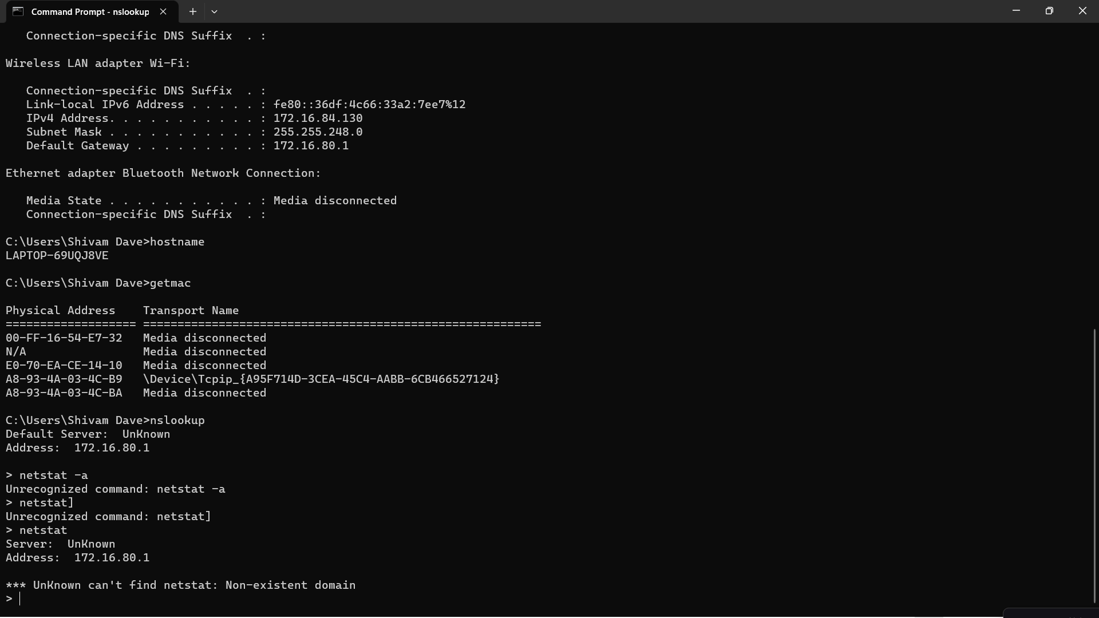

**7.Route:**

**Uses:**

The route command displays the computers routing table.

A typical computer, with a single network interface, connected to a LAN, with a router is fairly simple and generally doesn’t pose any network problems.

**Syntax**:

route

**Output:**

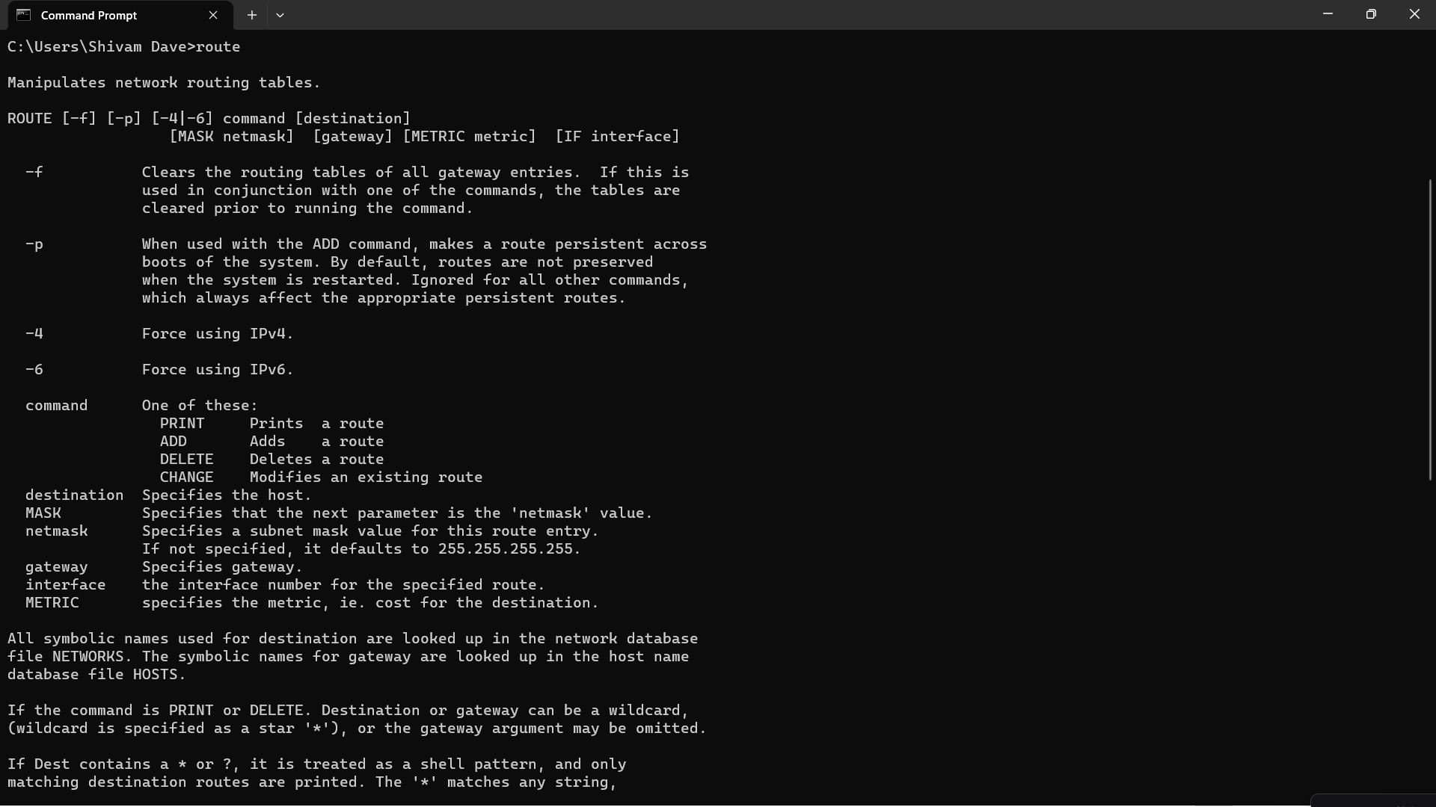

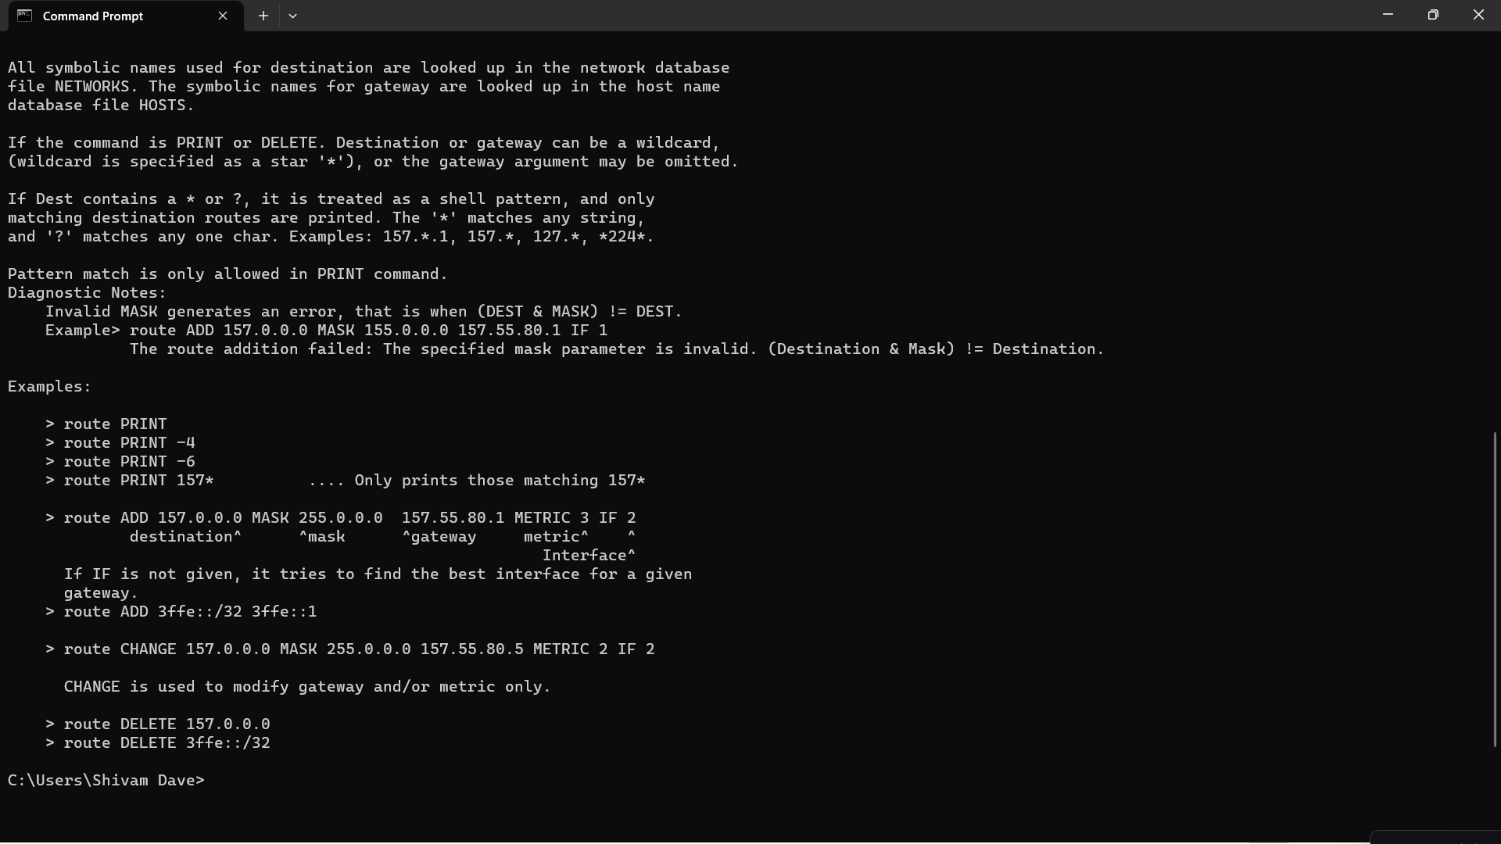

**8.Tracert:**

**Uses:**

The tracert command displays a list of all the routers that a packet has to go through to get from the computer where tracert is run to any other computer on the internet.q

**Syntax**:

**tracert** [**-d**]

**Output:**

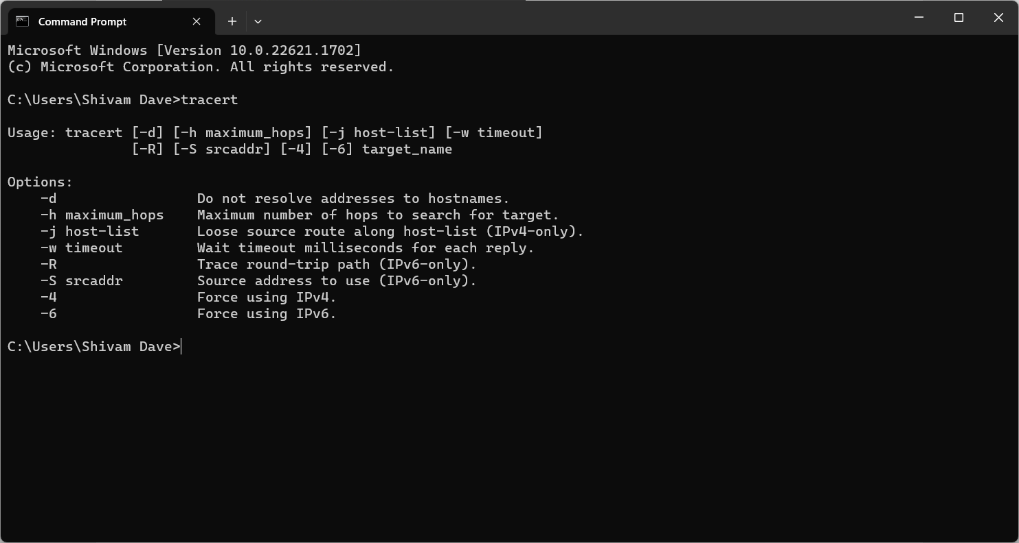

**9. tcpdump**

**Uses:**

tcpdump is a packet analyzer that is launched from the command line. It can be used to analyze network traffic by intercepting and displaying packets that are being created or received by the computer it's running on.

**Syntax**: tcpdump

**10.telnet**

**Uses:**

TELNET is commonly used by terminal emulation programs that allow you to log into a remote host. However, TELNET can also be used for terminal-to-terminal communication and interprocess communication. The **telnet** command is used to create a remote connection with a system over a TCP/IP network. It allows us to administrate other systems by the terminal. We can run a program to conduct administration.

**Syntax**: telnet hostname/IP address.

**Q3)Code for finding the Class of the Network**

#include<bits/stdc++.h>

using namespace std;

char Findclass(char cls[])

{

    char ans[4];//to store the first octet in a particular character array

    int i=0;

    // for(int x=0;x<12;x++)

    // {

    //     if(cls[i]=='.')

    //     {

    //         ans[i]=cls[i];

    //         i++;

    //     }

    //     else

    //     {

    //         i--;

    //     }

    while(cls[i]!='.')

    {

        ans[i]=cls[i];

        i++;

    }

    i--;

    int j=0,k=1;

    while(i>=0)

    {

        j=j+(cls[i]-'0')*k;

        k=k*10;

        i--;

    }

    if( j>=0 && j<=127)

    {

        return 'A';//class a

    }

    else if(j>127 and j<=191)

    {

        return 'B';//class b

    }

    else if(j>191 and j<=223)

    {

        return 'C';//class c

    }

    else if(j>223 and j<=239)

    {

        return 'D';//class d

    }

    else if(j>239 and j<=255)

    {

        return 'E';//class e

    }

}

int main()

{

    cout<<"Enter ip address:";

    char cls[12];

    cin>>cls;

    char ip=Findclass(cls);

    cout<<"Given IP address belongs to the class: "<<ip;

}

**OUTPUT:**

